The Catskill Center for Conservation and Development
2016 Scholarship Application

Attention Seniors! The Catskill Center is offering an annual scholarship to seniors graduating from high schools in the Catskill Mountain Region that have a portion of their school district within the Catskill Park or “blue line.” The scholarship will be a minimum of $250 for one or more students to help offset the expenses of continuing education. The recipients for this scholarship will be selected by a committee of the Catskill Center’s Board of Directors based on the following criteria:

- Completion of the attached cover page.

- Academic achievement. Please submit a set of transcripts.

- Extracurricular activities. Please describe.

- Recommendations from two unrelated adults. Submit letters of recommendation.

- Future academic plans. Describe and submit proof of registration prior to receipt of scholarship.

- Please type a 500 to 1,000-word essay on one of the following topics:
- Describe a green business you would like to open in the Catskills
- The Catskill Park – What It Means to Me
- Conservation Creates Opportunity
- Living in the Catskills in 2030

The deadline for submittal of all documents is Friday, March 11, 2016.

Please email application to: kpalm@catskillcenter.org

Letters of Recommendation can be emailed, snail mailed, or faxed to:
Senior Scholarship Program
c/o Katie Palm
The Catskill Center
PO Box 504
Arkville, NY 12406
Fax - 845-586-3044

If you have any questions or comments, please call Katie Palm at 845-586-2611 or email kpalm@catskillcenter.org

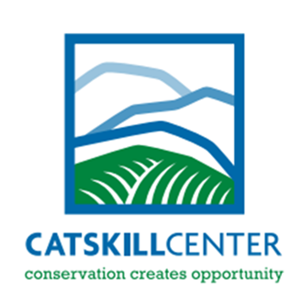
The Catskill Center for
Conservation and Development
2016 Scholarship Application

Name:_____________________________ High School:_____________________

Address:_________________________________________________________________

Email Address:________________________ Phone:___________________________

Please list names and relationship to you of people submitting recommendations:

- ____________________________________________________

- ____________________________________________________

Completed applications can be emailed to: Kpalm@catskillcenter.org

Completed letters of recommendation can be emailed, snail mailed, or faxed to:
Senior Scholarship Program
c/o Katie Palm
The Catskill Center
PO Box 504
Arkville, NY 12406
Fax - 845-586-3044

