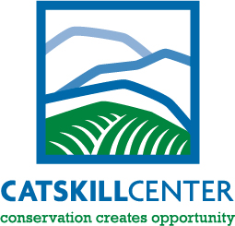
For Immediate Release

From: The Catskill Center

P.O. Box 504, Route 28, Arkville, NY 12406
Phone: 845-586-2611 Fax: 845-586-3044
E-mail: cccd@catskillcenter.org

Contact: Katie Palm: Catskill Center kpalm@catskillcenter.org (845) 586-2611

Catskill Interpretive Center announces new outdoor sculpture exhibit call for art.

ARKVILLE, NY— February 8, 2016: The Catskill Center is pleased to announce a Call for Art for sculpture which will be displayed at the outdoor sculpture park at the Maurice D. Hinchey Catskill Interpretive Center (CIC), located on Route 28. Art selected by the jury will be on display for one year beginning in early July.

Sculptors interested in exhibiting their work in the 2016-2017 Outdoor Sculpture Exhibition should submit a proposal by April 1 to Katie Palm at the Catskill Center, kpalm@catskillcenter.org. A jury of artists, art organization leaders, and community members will select pieces for the exhibit. The guidelines for submitting proposals can be downloaded from www.catskillcenter.org. Questions regarding the CIC Outdoor Sculpture exhibit can be addressed to Katie Palm at (845) 586-2611.

The CIC is a partnership with New York State DEC, New York City DEP, Catskill Watershed Corporation, other local non-profit organizations, and the Catskill Center - which will oversee the operations of the CIC. The CIC boasts beautiful meadows and a nature trail through wetlands, over hills, and along the banks of the Esopus. The Interpretive Center will host a three dimensional topographic map of the region as well as interactive touch panels to help visitors and residents alike plan a visit to the Catskill Park and Forest Preserve.

