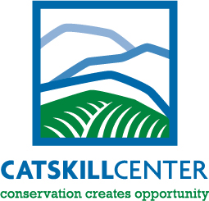

The Catskill Center for Conservation and Development
2015 Scholarship Application

Attention Seniors! The Catskill Center is offering an annual scholarship to seniors graduating from highs schools in the Catskill Mountain Region that have a portion of their school district within the Catskill Park or “blue line.” The scholarship will be a minimum of $250 for one or more students to help offset the expenses of continuing education. The recipients for this scholarship will be selected by a committee of the Catskill Center’s Board of Directors based on the following criteria:

- Academic achievement. Please submit a set of transcripts.

- Extracurricular activities. Please describe.

- Recommendations from two unrelated adults. Submit letters of recommendation.

- Future academic plans. Describe and submit proof of registration prior to receipt of scholarship.

- Please type a 1,000 to 1,500-word essay on one of the following topics:
- Describe a green business you would like to open in the Catskills
- The Catskill Park – What It Means to Me
- Conservation Creates Opportunity
- Living in the Catskills in 2030

The deadline for submittal of all documents is Friday, May 1, 2015.

Please mail to: Senior Scholarship Program
c/o Katie Palm
The Catskill Center
PO Box 504
Arkville, NY 12406

Or please email: kpalm@catskillcenter.org

Or fax to: 845-586-3044

If you have any questions or comments, please call Katie Palm at 845-586-2611.
Thank you, and good luck!

